Let’s go step-by-step and connect how **2D COCO keypoints** (x, y) still allow you to build **vectors** and compute **joint angles in 2D**, even though there’s no “z” depth.  
  
⸻  
  
🧠 1️⃣ **What you actually have in COCO**  
  
Each person = 17 keypoints shaped (17, 3)  
Example:  
  
[  
[x0, y0, v0],   # Nose  
[x1, y1, v1],   # Left Eye  
...  
[x7, y7, v7],   # Left Elbow  
[x9, y9, v9],   # Left Wrist  
...  
]  
  
So for the **left elbow** joint, you already have:  
  
**Joint** **Index** **Example (x, y)**  
Shoulder 5 (xₛ, yₛ)  
Elbow 7 (xₑ, yₑ)  
Wrist 9 (x𝓌, y𝓌)  
  
  
⸻  
  
🧮 2️⃣ **You can still form 2D vectors in the image plane**  
  
Even though there’s no “z”, you can define:  
U = S - E  
V = W - E  
  
That means:  
  
U = (xₛ - xₑ, yₛ - yₑ)  
V = (x𝓌 - xₑ, y𝓌 - yₑ)  
  
These are simply **2D direction vectors** in the image coordinate plane.

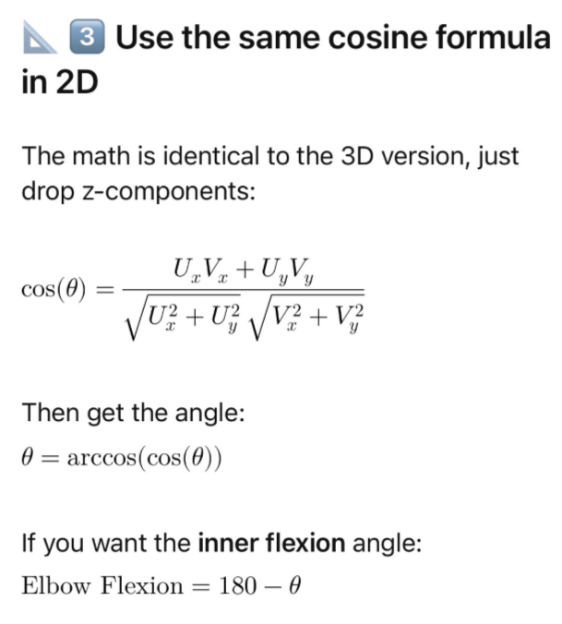

4️⃣ **Example (using COCO 2D points)**  
  
Suppose COCO gives:  
  
**Point** **(x, y) in pixels (ref. Taken from person_KP_default- annotation data )**  
Shoulder (300, 200)  
Elbow (350, 250)  
Wrist (400, 300)  
  
Then:  
  
U = (300 - 350, 200 - 250) = (-50, -50)  
V = (400 - 350, 300 - 250) = (50, 50)  
  
Dot product = (-50)(50) + (-50)(50) = -5000  
|U| = √(50² + 50²) = 70.71  
|V| = 70.71  
  
\cos(\theta) = -5000 / (70.71 * 70.71) = -1.0  
\Rightarrow \theta = 180°  
  
That’s a fully extended arm (straight line).  
  
If the wrist were higher or closer, the cosine would change and the elbow angle would decrease (arm flexed).

Where do you get these pixel points:

"id": 8,

"width": 412,

"height": 409,

"file_name": "Unsafe_Back_Unsupport_1.jpg", (Width= Right edge and height= bottom edge

In person keypoint "annotations": [

{

"id": 1,

"image_id": 1,

"category_id": 1,

"segmentation": [],

"area": 29636.487999999998,

"bbox": [

118.03,

66.31,

116.9,

253.52

],

"iscrowd": 0,

"attributes": {

"occluded": false,

"keyframe": false

},

"keypoints": [

152.35,-🡪 (Nothing but X -value is nothing horizontal pixel coordinate from left of image

79.48, -🡪 (Nothing but Y- value is nothing vertical pixel coordinate from Top of the image)

2, -🡪 Visibility flag (0= not labeled, 1= labeled but not visible and 2= visible0

149.73,

68.41,

1,